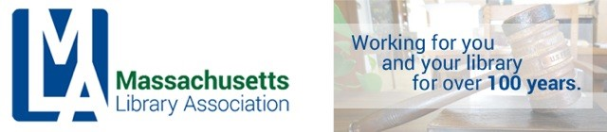

ADMINISTRATIVE BOARD MEETING
MARCH 25, 2016
WESTBOROUGH PUBLIC LIBRARY, 1 PM

Call to order
Approval of minutes of January 15, 2016 meeting
Review of draft of Interim Strategic Plan with Tracey Leger-Hornby
Treasurer’s report (emailed?)
President’s Report
Legislative Update
Conference issues—para, social media
Vice President’s Report
Nominating Committee Report
New Business
Adjourn

