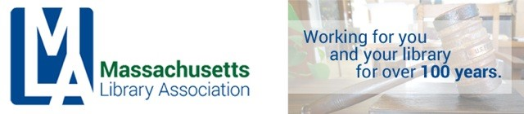

ADMINISTRATIVE BOARD MEETING
MAY 11, 2018
CONFERENCE CALL, 10 AM

Attending: Alex Lent, Jennifer Pike, William Adamczyk, Nora Blake, Jennifer Zolkos
Absent: Nanci Milone-Hill

Call to order
10:07am - Alex Lent

Treasurer’s Report – Jennifer Pike
- We are on track to meet income and spending goals for FY18

Acceptance of Treasurer’s Report: Nora moved, William seconded, all approved.

Other Business:
- Conference is shaping up well.
- The group planned the logistics of the Annual Meeting to be held on May 23, 2018 during the Annual Conference.

Adjournment
Meeting adjourned at 10:21am.

