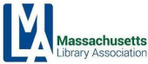

**MLA Executive Committee Agenda**

Friday, April 14, 2023, 10 – 12

Virtual Meeting via Zoom

Join Zoom Meeting  <https://us02web.zoom.us/j/82832523996>

Meeting ID: 828 3252 3996

1. Call to order

* Vote to approve the minutes of the February 10, 2023 meeting

1. President’s Report
2. Treasurer’s Report (Bernadette)
3. Association Manager’s Report (Rebecca)
4. Conference Update (Conference Committee Co-Chairs)
5. Committee Reports
6. Update

* MBLC
* MLS
* NELA
* MSLA
* Others

1. New Business
   * Fossil Fuel Divestment
2. Old Business
3. Adjournment

*\*Next meeting: Friday, June 9, 2023*



**Treasurer’s Report**

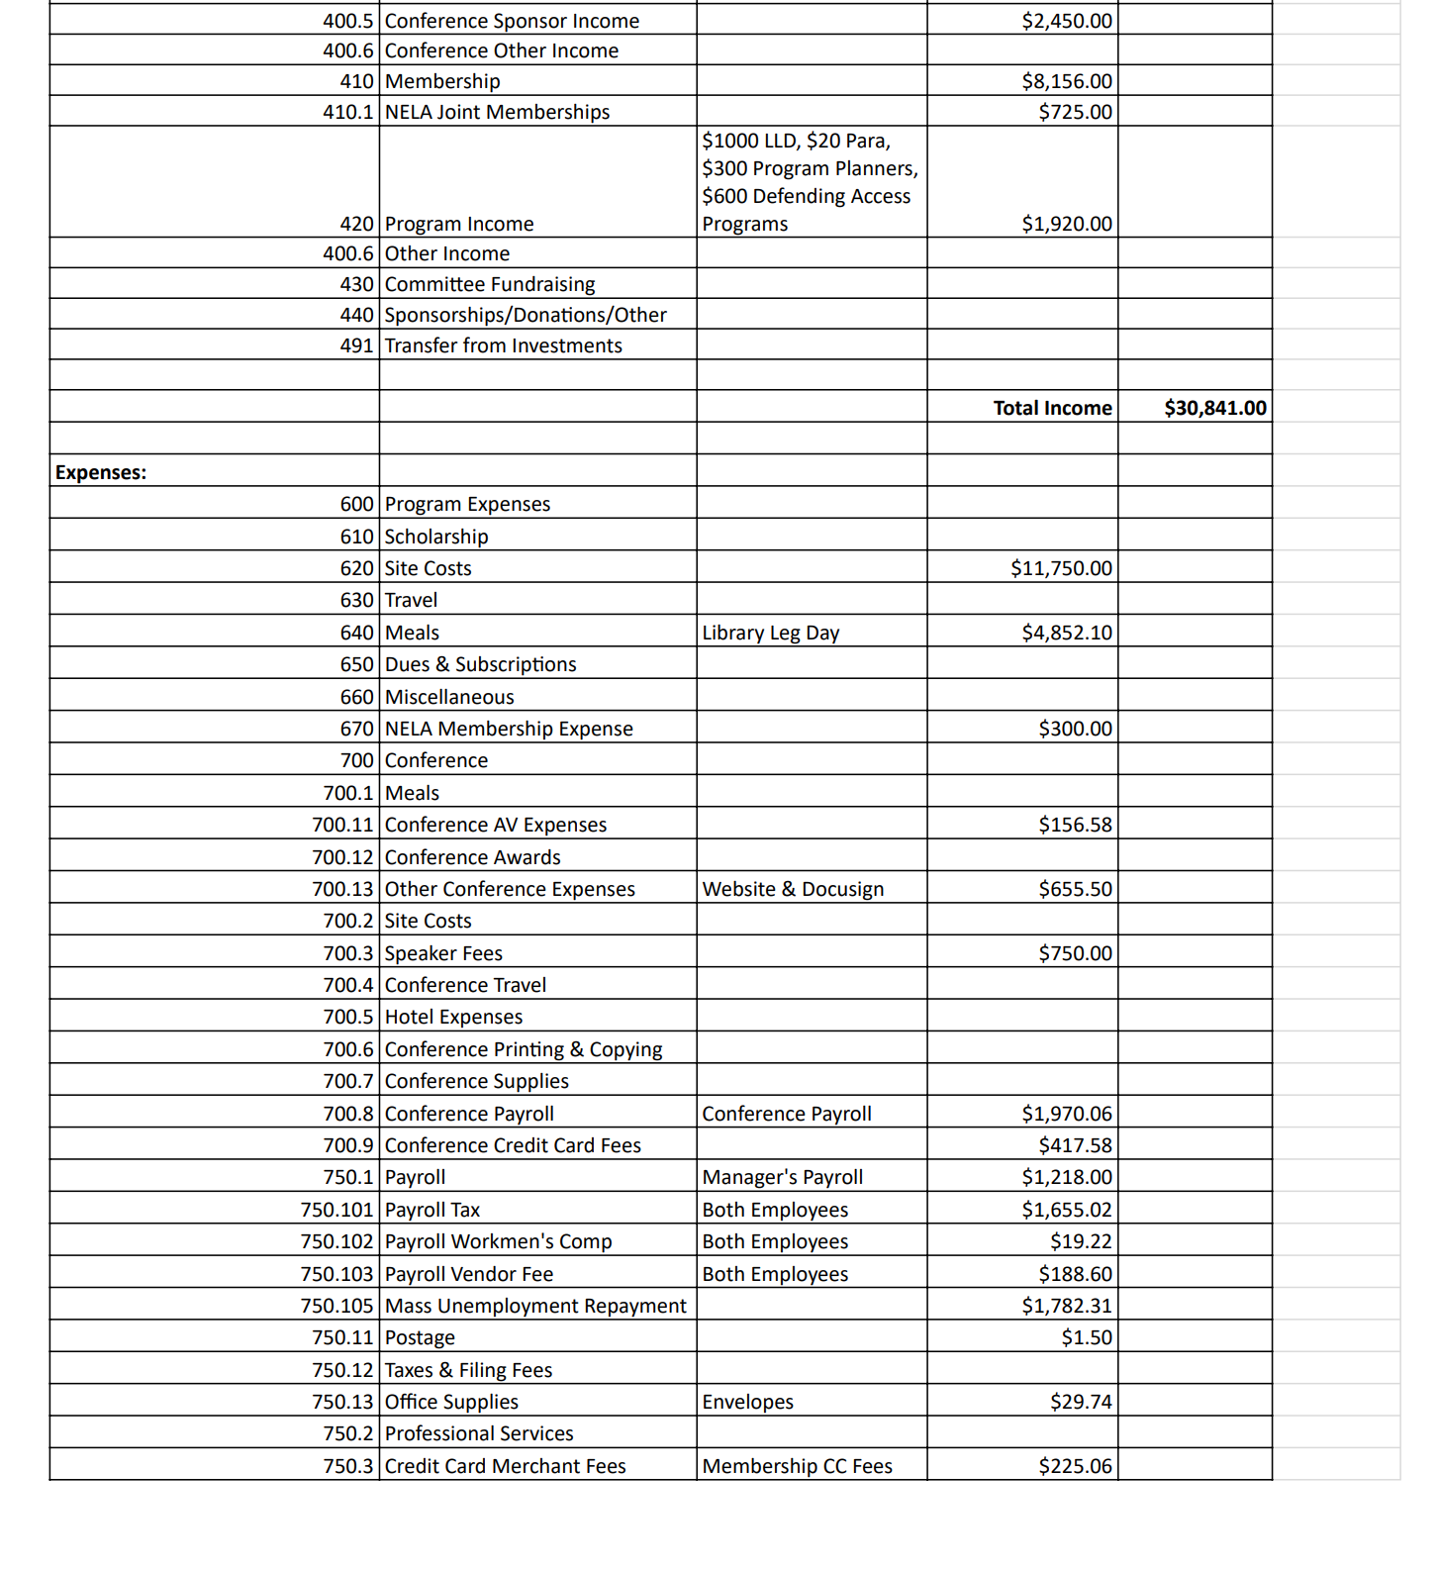



**Treasurer’s Report - continued**

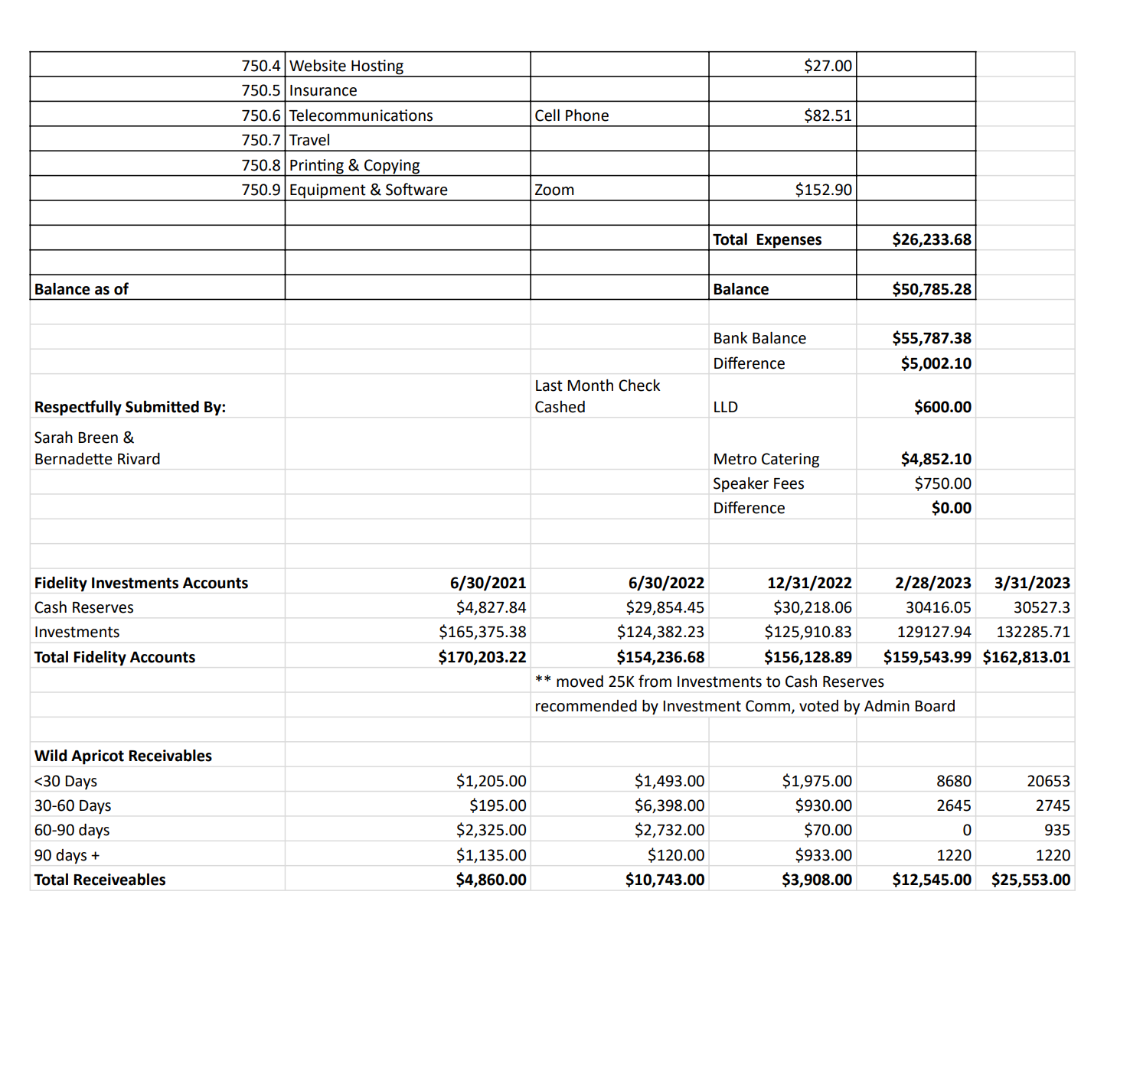

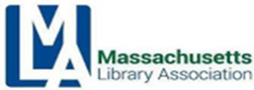

**MBLC Director’s Report to MLA Executive Board**

**April 2023**

Governor Healey released her **FY 2024 House 1 budget proposal** on March 1, 2023. Her recommendations for the MBLC budget lines include the Legislative Agenda-requested amounts for the MBLC agency administration, State Aid to Regional Libraries, State Aid to Public Libraries, and the Technology and Resource Sharing lines; 3% increases for the two talking book lines, and level funding for the Center for the Book. The chart references the current fiscal year budget, the MBLC request, and the Governor’s House 1 budget. The House Ways and Means Committee has begun conversations with House Members seeking their budget priorities for the FY 2024 fiscal spending plan. The House version of the budget will be decided in April and the Senate proposal will be debated and voted in May. A Conference Committee will meet to settle differences between the House and Senate versions in June ahead of the new fiscal year which starts July 1.



**Open Meeting Law Update**: On March 29, 2023, Governor Healey signed into law a bill which extends the temporary provisions pertaining to Open Meeting Law to March 31, 2025.  This further extension allows public bodies to continue holding meetings remotely without the chair and a quorum of the public body physically present at a meeting location, and to provide "adequate, alternative" access to remote meetings.

MLA and MSLA held a **virtual** **Library Legislative Day** event on March 8. This session was preceded by a “New Advocates” session. Chair Conrad and I presented during both sessions.

On March 15, Chair Conrad and I presented during our first in-person **Library Legislative Day** at the State House since 2019. I gave the legislative agenda briefings and Chair Conrad issued a call to action at the end of each session and during the luncheon speaker program.

Chair Conrad and I testified regarding the **FY2024 Legislative Agenda** in front of the **Joint Ways and Means Committee** on Friday, March 31 as part of their Economic Development/Housing/Labor hearing in Gloucester. We were asked questions about censorship, regionalization, and increased funding for MPLCP projects impacted by the pandemic. We also heard supportive comments about our work and the work of the Commonwealth’s libraries from



**MBLC Director’s Report to MLA Executive Board**

**April 2023 - continued**

legislators. A recording of the hearing is available at: <https://malegislature.gov/Events/Hearings/Detail/4468> (our portion starts at approx. 4 hours and 17 minutes)

**Trustee and Friends Group Outreach:** We held the following sessions in March:

3/7 Collection Development Policy Help  
3/9 Trustee Deep Dives: Hiring a New Director  
3/21 Friends Sharing with Friends Coffee  
3/29 Trustee Deep Dives: State Aid

Outreach continues in April with the following scheduled sessions:

4/4 Trustee Deep Dive: Q&A on Meeting Room and Collections Policies  
4/25 Trustee Deep Dive: Recruiting New Board Members  
4/26 Friends Sharing with Friends Coffee Hour

Paul Kissman helped to coordinate two **legal services webinars** in March. On March 9, *What Public Librarians Should Know About Consumer Debt Collection* covered the basics of consumer debt collection and provided guidance for public librarians regarding the services and support available to consumers in the Commonwealth. The session was presented by the Consumer Rights Unit at Greater Boston Legal Services. A recording is available at: <https://us02web.zoom.us/rec/share/94xaDuZ13MvoRyxYURuaGW9YEpKFvQBNextWru5C1dcOATWaF_LVOblNI7zZtrl2.R1qipILwsiqkucJx>

On March 30, the Massachusetts Trial Court’s **Access to Justice (A2J) Library Initiative** presented a webinar on the Initiative, which was first piloted at Norwood’s Morrill Memorial Library. The Library Initiative makes Trial Court virtual services, such as the Court Service Centers, Law Libraries, and Virtual Front Desks, more easily found by self-represented litigants who may struggle navigating the voluminous [Mass.gov](https://www.mass.gov/) website. For court users that are unable to access virtual court services at home for any reason, or who face challenges getting to the court in-person, local libraries can be the bridge that allows them to access justice through the courts.  The A2J Library Initiative is now live in other library locations, including Chelsea Public Library, Thomas Crane Library in Quincy, Milton Public Library, Forbes Library, and the Turner Free Library, and the Initiative is interested in expanding to other libraries throughout the state. The presentation slides are available at: <https://guides.mblc.state.ma.us/ld.php?content_id=71242036> and a recording of the session should be available soon.

Shelley Quezada worked with Michelle Eberle from MLS to coordinate the *Mental Health Supports and Libraries Series: Young Adults* webinar on March 10, 2023. The session included speakers allied with the Massachusetts Department of Mental Health about resources and supports for people experiencing mental illness. Heidi Holland, Director, Transitional Youth Services, Mass DMH and Young adults led the session that included a panel of young adults who shared their lived experiences. A recording is available on MLS Vimeo page: <https://vimeo.com/masslibsystem>



**MBLC Director’s Report to MLA Executive Board**

**April 2023 - continued**

On March 8, Rob Favini and Paul Kissmanattended the Massachusetts Broadband & Digital Equity Working Group meeting. The Working Group is composed of leaders from organizations

across Massachusetts with specific topic area expertise that represent target populations as defined by federal funding guidelines and MBI’s programs. At this first meeting, the group discussed the current state of Broadband and Digital Equity in the Commonwealth and pressing concerns such as funding for the Affordable Connectivity Program, ensuring inclusive stakeholder engagement and how to measure success.

The Communications Team worked closely with trainers on the two **crisis communications trainings** that were held in March. The team created a [support web page](https://mblc.state.ma.us/programs-and-support/library-advisory/crisis-communication.php) with helpful information including Intellectual Freedom (IF) Fact Sheets and tips for working with media. The IF Fact Sheets were also distributed at Library Legislative Day at the State House along with a construction bond sheet, and the new MPLCP construction map. Hundreds of Valentines were also distributed to legislators from our annual “Love Your Libraries” campaign.  
  
The MBLC partnered with the SAILS Network to create the **Ultimate Library Road Trip**, a fun way for residents to visit different libraries, experience resource sharing firsthand, and learn about what’s happening at the library and in the community. During April vacation week, residents can download a map and take the Ultimate Library Road trip. Visit <https://malibraryroadtrip.com/> for more information. The goal is to keep the site live after April and add libraries so that the road trip becomes statewide. The site will also link to the Massachusetts Center for the Book’s Mass Book Trails <https://www.massbook.org/mass-book-trails> and information from DCR.

In celebration of Financial Literacy Month, the MBLC’s partner, the **Office of Economic Empowerment**, developed a [booklet for libraries](https://mblc-newsroom-static.s3.amazonaws.com/collateral/campaigns/financial-literacy/53de4332_financial-literacy-activities-for-libraries-handbook-2023_download.pdf) with resources and activities for all ages. The [Financial Literacy Toolkit](https://mblc.state.ma.us/programs-and-support/promotion/toolkit-financial-literacy.php) on the MBLC website includes ready-made social media posts and a financial literacy calendar.  
  
The MBLC has started a partnership with the **Office of Veterans Services Women Veterans’ Network** to help bring awareness of Deborah Sampson, who was the first female veteran and a Massachusetts native. Rachel Masse is heading up efforts to develop library programming, events, and resources to raise awareness and celebrate important contributions from female veterans like Ms. Sampson. To learn more about Ms. Sampson, visit: <https://www.mass.gov/info-details/deborah-sampson-american-revolutionary-war-hero>

Finally, the PJ drive wrapped up in March. Libraries collected over 9,000 PJs for kids in need.



**MLS Update**

**April 2023**

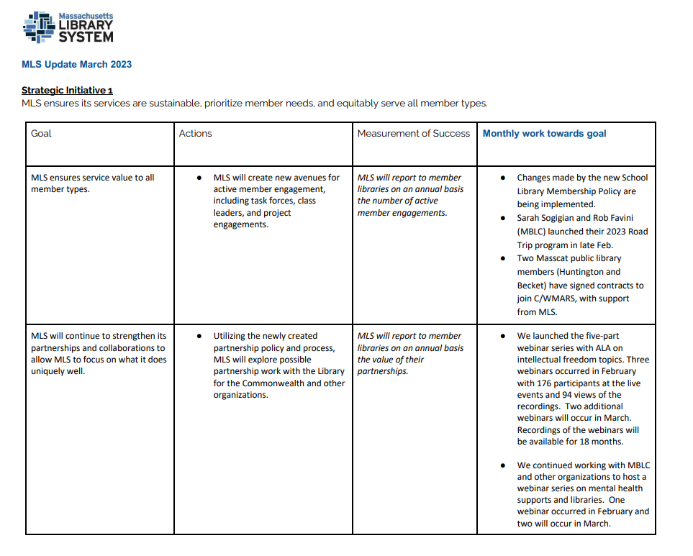



**MLS Update**

**April 2023 - continued**

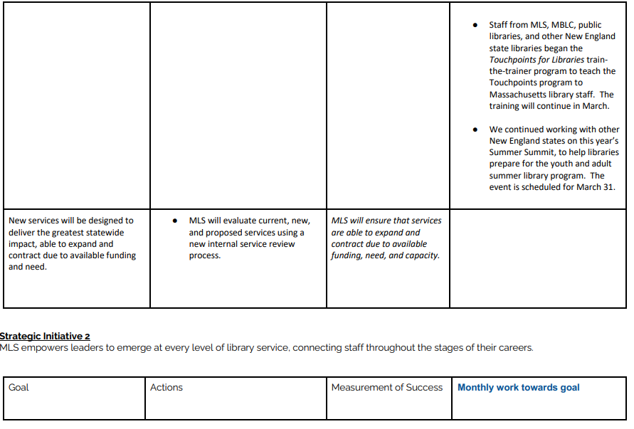

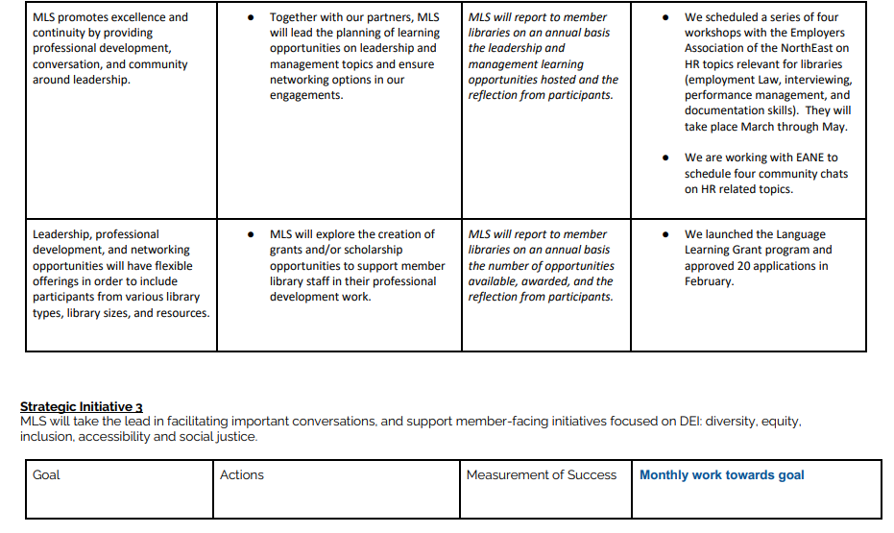



**MLS Update**

**April 2023 - continued**

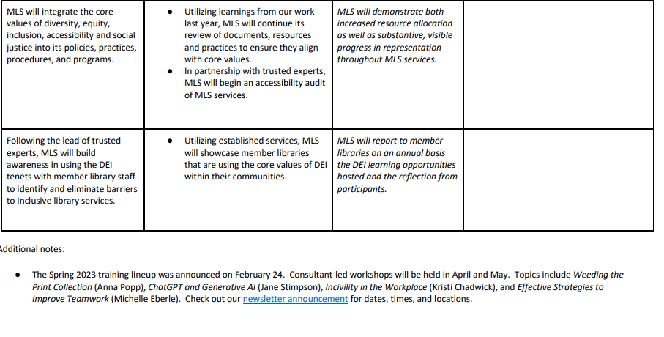

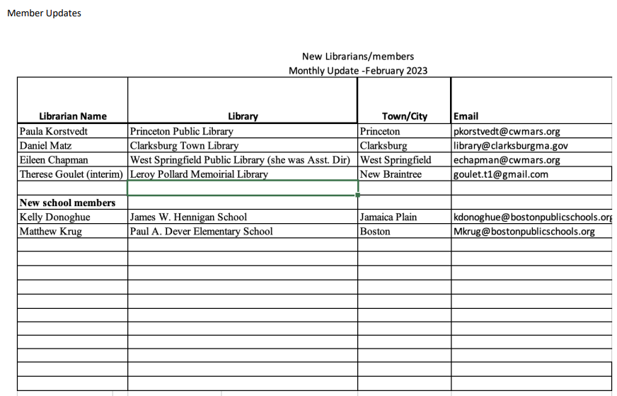

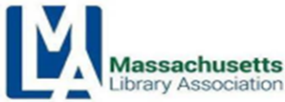

**Intellectual Freedom/Social Responsibility Committee**

**MLA Executive Board Report — April 2023**

**Past Activities:**

* With the help of MSLA, revised our Prepare/Respond to a Challenge Guide into two documents, one for schools, one for public libraries, posted on MLS IF Libguide: <https://guides.masslibsystem.org/intellectualfreedom>
* Co Chairs Susan Caulfield and Andrea Fiorillo attended Library Legislative Day at the state house to advocate for IF/SR issues and MBLC’s legislative agenda
* Andrea met with ALA OIF Chair Lesliediana Jones to offer a glimpse of what we’re seeing in MA around challenges and harassment prior to lobbying at the U.S. capitol
* Andrea presented on a panel for The Safe Schools Program for LGBTQ Students, a joint initiative between the MA Department of Elementary and Secondary Education and the MA Commission on LGBTQ Youth about challenges to collections, curricula, and services in schools and libraries
* Andrea was able to get a [Fight for the First](https://www.fightforthefirst.org) campaign started during a formal challenge to the Reading Public Library, both a “group” and petition were started. The petition against a book ban received over a thousand signatures within days. It will be presented to the reconsideration committee at RPL. FFF is a very valuable tool in pushing back against censorship.
* As local election season arrived, we saw an increase in challenges and harassment meant to influence elections. We consulted on cases where challenges were timed to drive voters to the polls with pro-censorship candidates on the ballot- including a school board member backed by Massachusetts Informed Parents in Westborough. Photos of MA Informed Parent and Massachusetts Family Institute campaign materials, meant to drive outrage over library materials and school curricula, are at the end of this report.
* We’ve seen an uptick in efforts to push parents to opt out of school lessons on anti-racist, LGBTQ, and sexual education.
* Participated in a regular IF Task Force meeting with MLS, MBLC, & MSLA
* Provided consultation with MLS to develop further IF training
* Attended the six part ALA/MLS IF webinar series
* Attended MBLC’s Crisis Communication training
* Participeted in Briefing on MA-Based Anti-LGBTQ Attacks MCLGBTQY
* Andrea presented to the public on censorship efforts in MA at the Salem Athenaeum, very engaged audience, getting the message out to lay people is vital to our success in punching back on censorship

**Upcoming and Ongoing Work:**

* MLA Conference 2023
* Consulting on cases of challenges to programs and collections
* Speaking with the media
* Our next informal meeting will be at Conference

**ellectual Freedom/Social Responsibility Committee**

**MLA Executive Board Report — April 2023**

Respectfully submitted,

Susan Caulfield and Andrea Fiorillo Co-Chairs, IF/SRC

Photos taken of pro- censorship campaign materials:

 [**20230325_200920.jpg**](https://drive.google.com/file/d/1za-qTXWRmnipUG6PC7ZhhJKDStmf7Mv3/view?usp=drive_web)

 [**20230325_200934.jpg**](https://drive.google.com/file/d/1o838GkJQvC3M4KWeWdE7fiizpmFbOlIP/view?usp=drive_web)

 [**20230325_201001.jpg**](https://drive.google.com/file/d/1qyLRDoE9qlWD_Th0fQX5x23p4WICz-Sy/view?usp=drive_web)

 [**20230325_201245.jpg**](https://drive.google.com/file/d/1DHiLuYKBQdkyOWpg1ycnap6pCVZntR6K/view?usp=drive_web)



**Interim Association Manager Monthly Activity Report**

**Name:** Kristen Collins

**Date:** April 2023

|  |  |
| --- | --- |
| **Member Relations** | * Managed incoming emails/inquiries/phone calls (most calls were spam) * Renewed memberships * Attended Feb 2023 E-Board meeting * Met with membership committee to discuss refreshing the membership program |
| **Technical** | * Downloaded the contacts report and archived 100s of contact w help from volunteer * Contacted WA to learn more about why the NELA discounted membership can’t be applied to more than one in a bundled membership * Merged some duplicate contact |
| **External Relations** | * Prepared NELA report and sent to NELA rep * Created new members via ALA |
| **Conference Management** | * Met with co-chairs regarding conference schedule * MLA registration fully launched * Managed exhibitor and sponsor event registration * Exhibitors are sold out * Sponsorships are lower than anticipated * Secured a better AV supplier * Followed up w PR committee re: plan * Prepared featured speaker graphics for PR team * Attended conference committee meetings * Interfaced with several exhibitors/sponsors * Sourced 2024 program and am in process of negotiating contract * Planned menus, specs for event * Secured 2 volunteers and 1 paid person to assist w/conference * Secured an overflow block for conference * Deployed communications * Worked w graphic designer to build out print program |
| **Finance** | * Created custom invoices for conference registrants for payment * Worked w Bernadette to close an old online payment subscription that we no longer used |
| **Next steps** | **Conference:**   * Continue to manage event registrations/custom invoices * Work w/co-chairs to fine tune additional details an * Update website with edits * Fine-tune event management details |



**Library Information Technologies Section (LITS)**

**Executive Committee Report — April 2023**

MLA’s Library Information Technologies Section (LITS) has focused its energy this Winter and Spring on administrative and organizational needs so that the Section is ready for the upcoming Summer and new term. We believe that an organized Section will make it more appealing, and easier, for new Members to get involved and lead in the years ahead.

**Summary of Activities:**

* Monday, February 12: LITS held a meeting by Zoom. We were pleased to welcome a new Member, celebrated good news from our existing Members, and wrapped up the discussion around By-laws and Conference Committee responsibilities. LITS Chair, Andrea Puglisi, expresses her gratitude for the contributions of the By-laws revision subcommittee who have put in significant thought and work on making a sustainable MLA LITS moving forward.
* Saturday, April 8, 2023: LITS Chair put forward to the entire MLA LITS Membership LITS’ sub committee's [proposed By-Laws](https://docs.google.com/document/d/1RMeW32q1VPaAzxh3DFa7r5dWCe8fW-iKmbzeMc2kVdU/edit?usp=sharing). Voting will wrap up by Saturday, May 6th just in time for MLA’s Spring Conference.
* LITS continues to fulfill its responsibilities to the Conference Committee.

**Emerging Focus:**

* LITS Chair Andrea Puglisi is working to identify anyone who would like to serve in LITS Leadership as part of the next term. LITS currently has a vacant Vice Chair position, which we hope to rename to Co-Chair, depending on the outcome of LITS By-laws revision vote.

Respectfully submitted,

Andrea Puglisi, LITS Chair

April 8, 2023



**Personnel Issues & Education Committee (PIE)**

**April 2023 Report**

PIE last met on Apr 10, 2023.

PIE is working on several initiatives and potential partnerships.

* We will shortly be posting on our webpage some alternative sites that libraries can use to post jobs to if they wish to diversify where they list to. Simmons College LIS (SLIS) program may also be a source of other sites that we are investigating.
* PIE wants to find a way to create a mentorship program across all levels of positions for library staff. SLIS is apparently also interested in starting a similar program, so PIE is waiting to hear what they are looking at doing to see if there is a way for us to partner. We would want to make sure there is a safeguard in place so that both mentor and mentee are protected in case the mentorship is unfavorable to either side.
* Noelle met with James Lonergan and Rob Favini of the MBLC to talk about the possibility of partnering around scholarships for marginalized populations to attend library school. It was agreed there were many potential obstacles to that and to provide meaningful monetary support. The conversation then turned to the idea of instead funding paid internships for high school or college students in libraries, potentially in Gateway Cities, that could encourage diverse peoples to become interested in the library as a profession. James and Rob will investigate looking at groups like CityYear or Americorp as possible models on how to run an internship program with an eye towards DEI.
* PIE will also be shortly posting on their webpage a list of volunteer or internship tasks that could be jumping off points for those looking to offer something.

Next meeting: Monday, June 12th at 2pm

We welcome anyone interested!

Respectfully submitted,

Noelle Boc, Chair



**MLA Legislative Committee Report**

April 2023

The Legislative Committee held its most recent meeting on February 17, 2023, which was the final Library Legislative Day Subcommittee meeting to review final arrangements for the legislative events; this was not a full committee meeting. There was no meeting in March, as all focus was on the March events.

MLA/MSLA 2023 Library Legislative Events:

* March 8, 2023 – Virtual events
  + Close to 100 people attended the Legislative Committee’s virtual session for New Advocates
  + Another 100 individuals attended the virtual Library Legislative Day
  + Recordings of these sessions are now available at [masslib.org](http://masslib.org/). (apologies: one of the recordings was cut off at the beginning)
* March 15, 2023 – Library legislative Day (LLD) at the MA State House
  + close to 300 people joined us at the State House, despite weather and other obstacles.
  + It was exciting to be back in person, there were 30+ legislators who were represented at the event; This was our largest group of new attendees ever.
  + Representative Ruth Balser was presented with MLA’s Library Advocacy Award in recognition of her ongoing work for the Commonwealth's libraries, especially with her library ebook legislation [H.3239](https://malegislature.gov/Bills/193/H3239/Cosponsor), which now has over 20 cosponsors, largely due to direct action by library advocates taken during and shortly following LLD 2023. We are still asking library workers and advocates to contact their legislators to cosponsor this bill.

More on Ebooks

* Library Futures has created a new website, [The EBook Study Group](https://ebookstudygroup.nationbuilder.com/). “The eBook Study Group invites interested stakeholders to be a part of this multi-state movement to address these issues of digital rights and library equity. Please sign up now for our irregular newsletter to stay in touch.” We recommend all board members check it out.

Conference:

* The Legislative Committee is sponsoring the session, “Feeling the Pain: Libraries Ongoing Struggles with eBook Restrictions,” on Tuesday, May 9 at 1:15 pm. Panelist include: Steve Potash Founder and CEO of Overdrive; Juliya Ziskina, Policy Fellow for Library Futures; and State Rep. Ruth B. Balser, 12 Middlesex District and lead sponsor of H.3239, An Act empowering library access to electronic books and digital audiobooks.

Respectfully submitted,

Will Adamczyk and Eileen Dyer

Cochairs, MLA Legislative Committee



**Paralibrarian Section**

**Report to the Executive Board, April 2023**

We continue to offer our meetings virtually via Zoom our last one was on April 11, 2023.

On March 21st we meet in person on March 21st with a newly formed subcommittee to address upgrading our Certification process to a digital platform to minimize the paper. We will reach out to our MLA manager for her input and suggestions.

The section will award three PARA Certifications this year. Two level twos and one Level three. The certificates will be presented to participants at the Paraganza before our Annual meeting. (Please see attached list)

The selection of our MLA Paralibrarian Section Award for Outstanding Library Support Staff and our MLA Paralibrarian Section Award for Library Support Staff Advocate was completed and the winners will be announced at our paraganza at the MLA Conference immediately after our Dynamic Duo’s program.

Our Vice Chair has continued her work with the MLA PR committee for social media out reach.

We continue to reach out to others paralibrarians to join our committee.

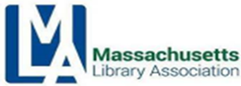

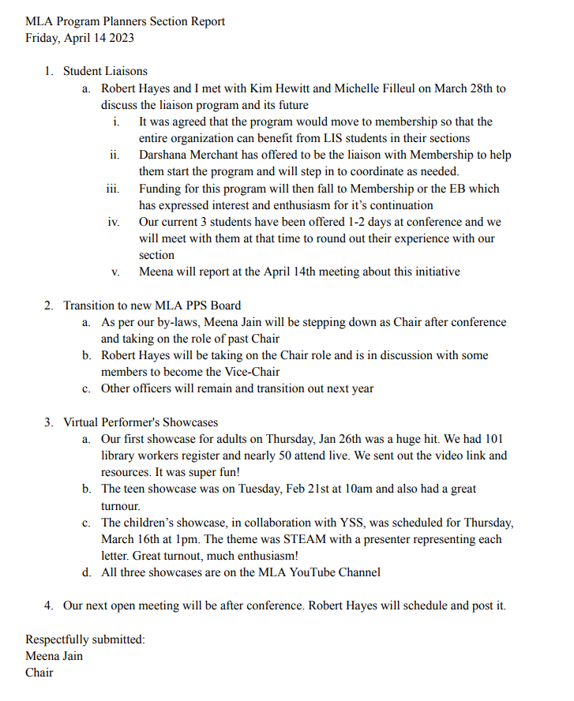



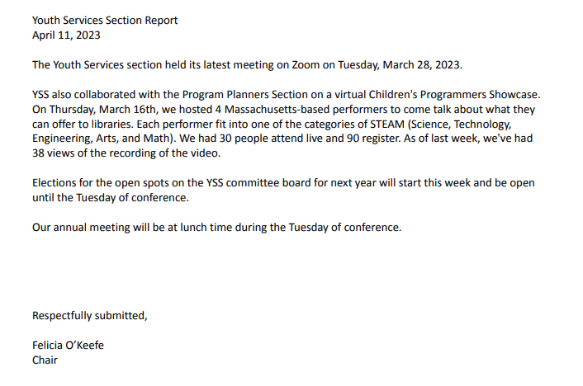



**2023-2024 Election MLA Officers**

**VOTING RESULTS April 7, 2023**

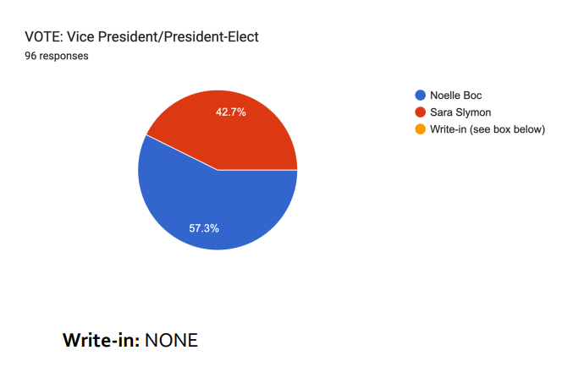

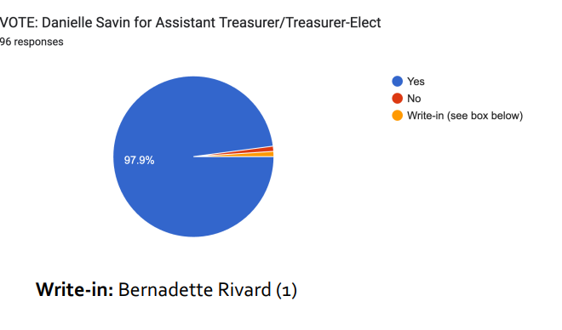



**2023-2024 Election MLA Officers**

**VOTING RESULTS April 7, 2023**

